**ASSIGNMENT DAY 1- CORE JAVA**

**ASSIGNMENT-1**

ANSWER 1.

import java.util.*;

public class Main {

public static void main(String[] args) {

int unit;

Scanner ob =new Scanner(System.in);

unit=ob.nextInt();

CalculateBill c=new CalculateBill();

c.generate(unit);

}

}

class CalculateBill

{

public void generate(int n)

{

double amount=0;

if(n<100)

{

amount=100*1.2;

}

if(n<=300)

{

amount=100*1.2+(n-100)*2;

}

if(n>300)

{

amount=100*1.2+(n-200)*2+(n-300)*3;

}

System.out.println("YOUR BILL IS :" +amount);

}

}

OUTPUT 1:



**ASSIGNMENT-4**

ANSWER :

**public** **class** Banking {

**public** **static** **void** main(String[] args) {

Account a1=**new** Account();

a1.setAcno(101);

a1.setAcbal(50000);

a1.setPassword("abc@123");

Account.*setBankName*("HDFC");

a1.displayAccount();

}

}

**class** Account

{

Account()

{

System.***out***.println("ACCOUNT CLASS CONSTRUCTOR");

}

**private** **int** acNo;

**private** **int** acBal;

**private** String passWord;

**public** **static** String *bankName*;

**public** **void** setAcno(**int** acNo) {

**this**.acNo = acNo;

}

**public** **void** setAcbal(**int** acBal) {

**this**.acBal = acBal;

}

**public** **void** setPassword(String passWord) {

**this**.passWord = passWord;

}

**public** **static** **void** setBankName(String bn) {

*bankName* = bn;

}

**void** displayAccount()

{

System.***out***.println("ACCOUNT NUMBER IS :" + acNo);

System.***out***.println("ACCOUNT BALANCE IS :" + acBal);

System.***out***.println("ACCOUNT PASSWORD IS :" + passWord);

System.***out***.println("BANK NAME IS :" + *bankName*);

}

}

OUTPUT:

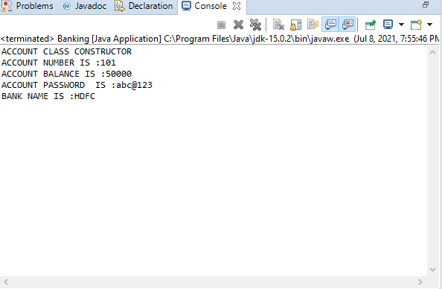

ASSIGNMENT-2

ANSWER:

**import** java.util.*;

**public** **class** Innings {

**public** **static** **void** main(String[] args) {

// **TODO** Auto-generated method stub

**int** overs=5;

Scanner ob=**new** Scanner(System.***in***);

**int** runs[]=**new** **int**[overs];

System.***out***.println(" ENTER RUNS SCORED BY BATSMAN IN 5 OVERS");

**for**(**int** i=0;i<overs;i++)

{

runs[i]=ob.nextInt();

}

**int** sum=0;

**float** avg=0;

**int** count=0;

**int** count1=0;

**int** count2=0;

**int** count3=0;

**int** count4=0;

**int** count6=0;

**for**(**int** i=0;i<overs;i++)

{

sum=sum+runs[i];

**if**(runs[i]==0)

count++;

**else** **if**(runs[i]==1)

count1++;

**else** **if**(runs[i]==2)

count2++;

**else** **if**(runs[i]==3)

count3++;

**else** **if**(runs[i]==4)

count4++;

**else** **if**(runs[i]==6)

count6++;

}

avg=sum/5;

System.***out***.println("TOTAL RUNS IN 5 OVERS ARE:" +sum);

System.***out***.println("NUMBERS OF 0S IS:" +count);

System.***out***.println("NUMBER OF 1S IS:" +count1);

System.***out***.println("NUMBER OF 2S IS:" +count2);

System.***out***.println("NUMBER OF 3S IS:" +count3);

System.***out***.println("NUMBER OF 4S IS:" +count4);

System.***out***.println("NUMBER OF 6S IS:" +count6);

System.***out***.println("BATSMAN RATE IS:" +avg);

}

}

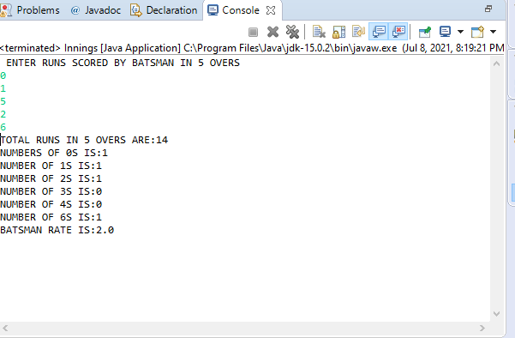

**ASSIGNMENT-3**

ANSWER:

**public** **class** Innings {

**public** **static** **void** main(String[] args) {

// **TODO** Auto-generated method stub

**int** sum=0;

**float** avg=0;

**int** count=0;

**int** count1=0;

**int** count2=0;

**int** count3=0;

**int** count4=0;

**int** count6=0;

**for**(**int** i=0;i<5;i++)

{

**for**(**int** j=0;j<30;j++)

{

**double** random_no=Math.*random*();

**int** runs=(**int**)(random_no*6);

sum=sum+runs;

**if**(runs==0)

count++;

**if**(runs==1)

count1++;

**if**(runs==2)

count2++;

**if**(runs==3)

count3++;

**if**(runs==4)

count4++;

**if**(runs==6)

count6++;

}

}

avg=(sum*100)/150;

System.***out***.println("TOTAL RUNS IN 5 Matches ARE:" +sum);

System.***out***.println("NUMBERS OF 0S IS:" +count);

System.***out***.println("NUMBER OF 1S IS:" +count1);

System.***out***.println("NUMBER OF 2S IS:" +count2);

System.***out***.println("NUMBER OF 3S IS:" +count3);

System.***out***.println("NUMBER OF 4S IS:" +count4);

System.***out***.println("NUMBER OF 6S IS:" +count6);

System.***out***.println("BATSMAN RATE IS:" +avg);

}

}

OUTPUT:-

